**PROJECT REPORT**

ON

**SCIENTIFIC CALCULATOR**

**SUBMITTED BY:**

ADITI CHOUBEY (RA2111026010062)

NEHAL GUPTA (RA2111026010065)

MARNI YASWANTH (RA2111026010038)

BHARATH S (RA2111026010058)

**SCIENTIFIC CALCULATOR**

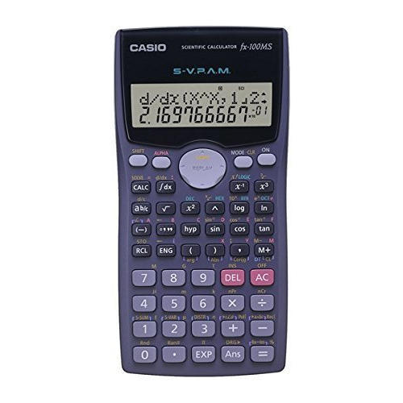

# **TABLE OF CONTENTS**

# Introduction

# Basic functions

# Algorithm

# Flow Chart

# Source Code

# Applications

# Future Aspects

**INTRODUCTION**

**Scientific Calculator**:

### The calculator was written by Rolf Howarth in early 1996.

A digital calculator is a type of [electronic](https://en.wikipedia.org/wiki/Electronics) [calculator](https://en.wikipedia.org/wiki/Calculator), usually but not always handheld, designed to calculate problems in [science](https://en.wikipedia.org/wiki/Science), [engineering](https://en.wikipedia.org/wiki/Engineering), and [mathematics](https://en.wikipedia.org/wiki/Mathematics). They have completely replaced [slide rules](https://en.wikipedia.org/wiki/Slide_rule) in traditional applications, and are widely used in both education and professional settings.

A fully featured scientific calculator with proper operator precedence is implemented, including trigonometric functions and logarithms, factorials, 12 levels of parentheses, logs to base 2 (a handy function for information entropists!), bitwise logical operators, hex, octal, binary and ASCII display.

**BASIC FUNCTIONS**

**Addition**

The addition (sum function) is used by clicking on the "+" button or using the keyboard. The function results in a+b.

**Subtraction**

The subtraction (minus function) is used by clicking on the " -" button or using the keyboard. The function results in a-b.

**Multiplication**

The multiplication (times function) is used by clicking on the “*” or using the keyboard. The function results in a*b.

**Division**

The division (divide function) is used by clicking on the "/" button or using the keyboard "/" key. The function results in a/b.

**Square Root**

The square root function is used by typing "sqrt()". This function represents x^0.5 where the result squared is equal to x.

**Square**

The square function is used by clicking on the "x^2" button or type "^2". The function results in x*x.

**Cube**

The cube of a function is used by clicking on the “x^3”. The function results in x*x*x.

**Raise to the Power**

The raise to the power (x raised to the y function) is used by clicking on the "x^y" button or type "^"

**Inverse**

Multiplicative inverse (reciprocal function) is used by pressing the "1/x" button or typing "inv()". This function is the same as x^-1 or dividing 1 by the number.

**Cube Root**

The function results in x^1/3.

**x^1/y**

The function results in x raised to power inverse of y. (x^1/y).

**10^x**

The function results in 10 raised to power x.

**Factorial**

The Factorial function is used by clicking "!" button or type "!". The result is (x)(x-1)(x-2)…(x-n).

**Percentage**

The function converts the number to percentage.

**Modulus**

The function is used by clicking “%” on keyboard. It results in remainder of x/y.

**Logarithm**

The logarithm (log) is used by clicking on the "log" button or type "log()".

**Trigonometric functions**

The function results in sine, cosine, tangent, cotangent, secant and cosecant of the angle.

**ALGORITHM**

Step 1: BEGIN.

Step 2: PRINT ENTER YOUR CHOICE.

Step 3: ENTER YOUR CHOICE.

Step 4: USER WILL ENTER

+ , -,*,/,*/, /3, inverse,x^y,10^x,x!, %, mod, log(x), sin(x),cos(x), tan(x), cosec(x),sec(x),cot(x).

Step 5: SWITCH(OPERATOR)

Step 6: DO THE OPERATION.

Step 7: PRINT THE RESULT.

Step 8: EXIT.

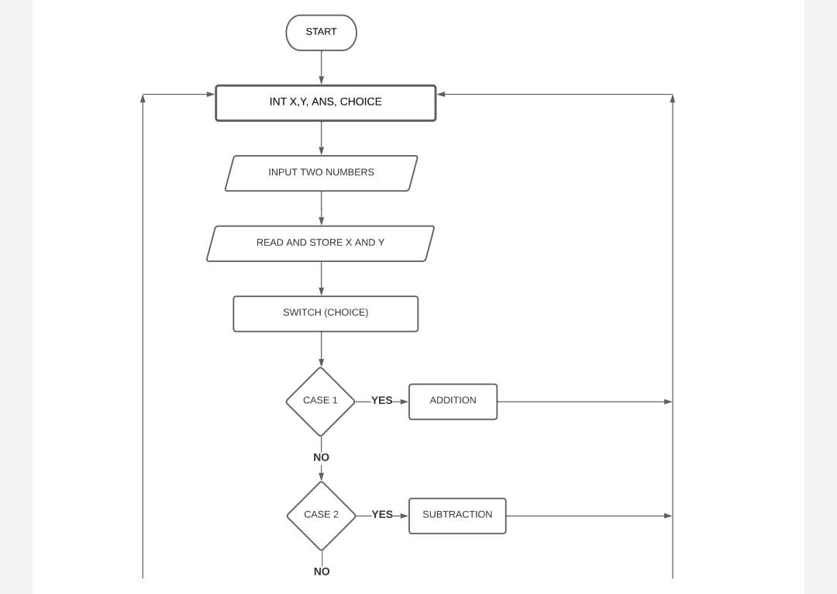**FLOWCHART**

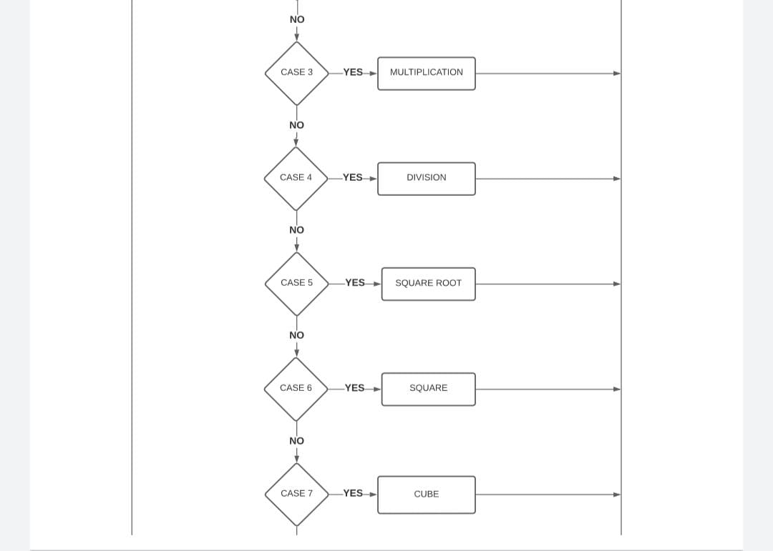

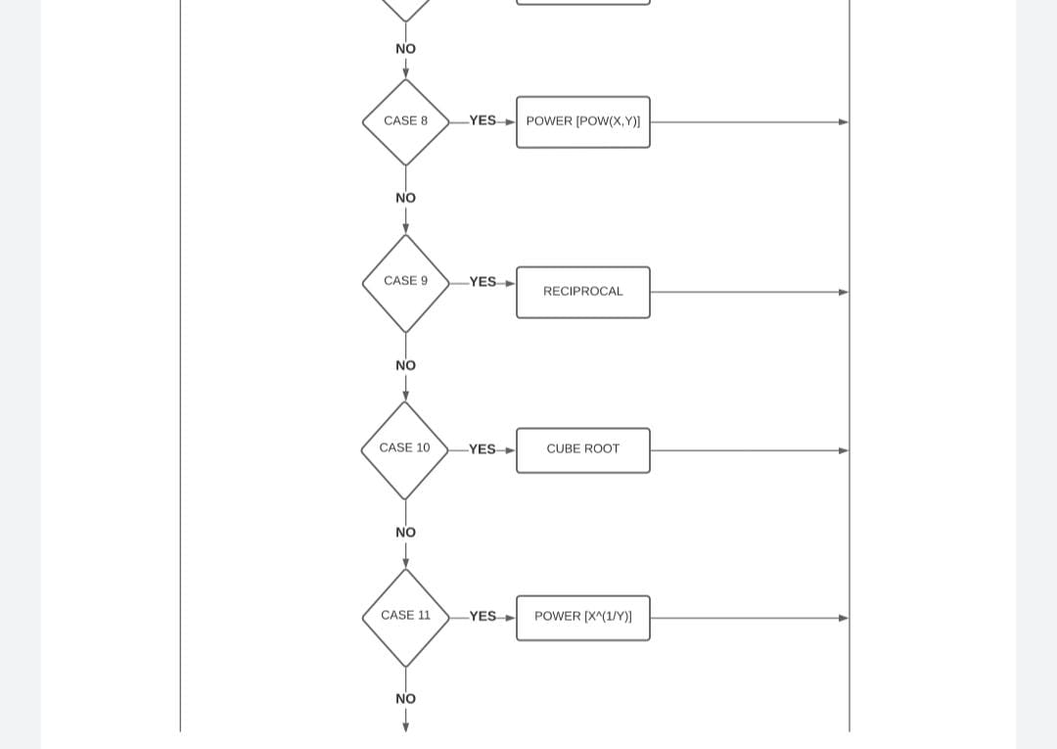

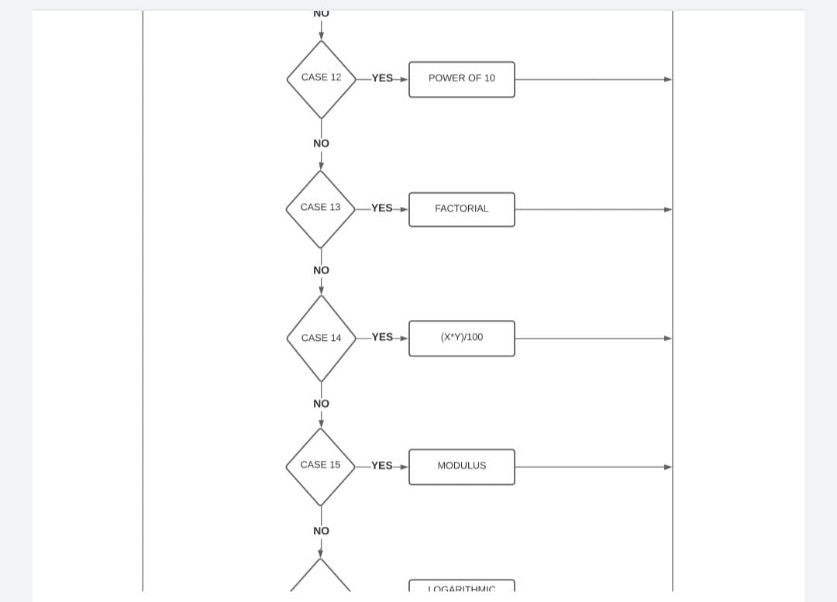

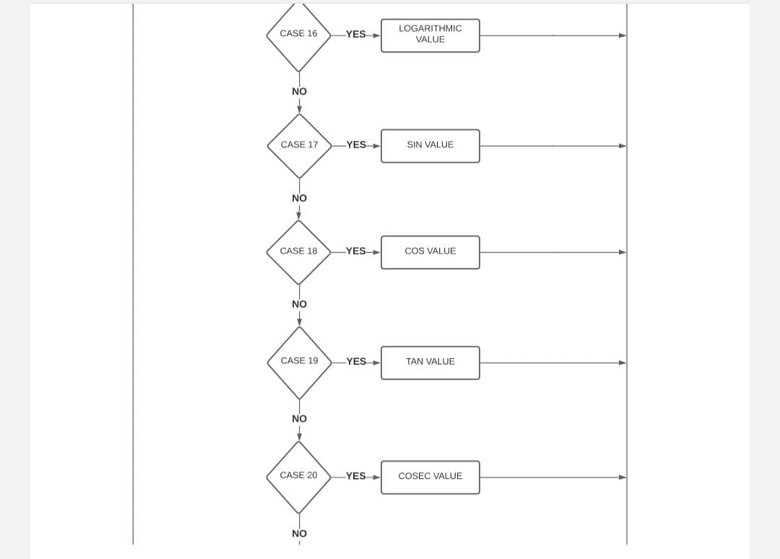

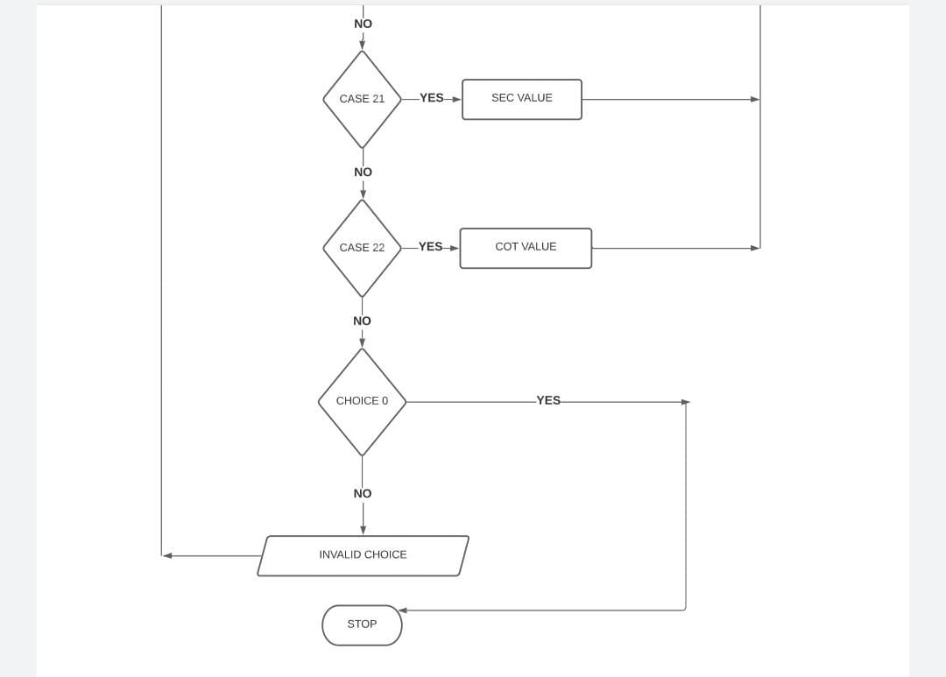

**SOURCE CODE**

#include<stdio.h>

#include<stdlib.h>

#include<math.h>

#define pi 3.14159

int main(void)

{

int c,i,p,q,a;

float x, y, ans;

do {

printf("\nSelect operation: (0 to exit):\n");

printf(" 1 for Addition\n 2 Subtraction\n 3 for Multiplication\n 4 for Division\n 5 for Square root\n 6 for Square of x \n 7 for cube of x \n 8 for x^y\n 9 for 1/x \n 10 for x^(1/3) \n 11 for x^(1/y)\n");

printf(" 12 for 10^x \n 13 for x! \n 14 for percentage \n 15 for Modulus\n 16 for log10(x)\n 17 for sin(x)\n 18 for cos(x) \n 19 for tan(x) \n 20 for Cosec(X)\n 21 for sec(x) \n 22 for cot(x)\n");

printf(" Enter you choice: ");

scanf("%d",&c);

if(c==0)

exit(0);

switch(c){

case 1:

printf("Enter the value of x and y respectively:");

scanf("%f %f",&x,&y);

ans=x+y;

printf("\n Answer is: %f",ans);

break;

case 2:

printf("Enter the value of x and y respectively:");

scanf("%f %f",&x,&y);

ans=x-y;

printf("\n Answer is: %f",ans);

break;

case 3:

printf("Enter the value of x and y respectively: ");

scanf("%f %f",&x,&y);

ans=x*y;

printf("\n Answer is: %f",ans);

break;

case 4:

printf("Enter the value of x and y respectively: ");

scanf("%f %f",&x,&y);

ans=x/y;

printf("\n Answer is: %f",ans);

break;

case 5:

printf("Enter the value of x:");

scanf("%f",&x);

ans=sqrt(x);

printf("\nAnswer is:%f",ans);

break;

case 6:

printf("Enter the value of X:");

scanf("%f",&x);

ans= x*x;

printf("\n Answer is:%f",ans);

break;

case 7:

printf("Enter the value of x: ");

scanf("%f",&x);

ans=pow(x,3);

printf("\nAnswer is: %f",ans);

break;

case 8:

printf("Enter the value of x and y respectively: ");

scanf("%f %f",&x,&y);

ans=pow(x,y);

printf("\nAnswer is :%f",ans);

break;

case 9:

printf("Enter the value of x: ");

scanf("%f",&x);

ans=pow(x,-1);

printf("\nAnswer is: %f",ans);

break;

case 10:

printf("Enter the value of x: ");

scanf("%f",&x);

ans=pow(x,(1/3));

printf("\n Answer is: %f",ans);

break;

case 11:

printf("Enter the value of x and y respectively: ");

scanf("%f %f",&x,&y);

ans=pow(x,(1/y));

printf("\nAnswer is: %f",ans);

break;

case 12:

printf("Enter the value of x: ");

scanf("%f",&x);

ans=pow(10,x);

printf("\nAnswer is: %f",ans);

break;

case 13:

printf("Enter the value of x: ");

scanf("%f",&x);

ans=1;

for(i=1;i<=x;i++) {

ans*=i;

}

printf("Answer is: %.f",ans);

break;

case 14:

printf("Enter the value of x: ");

scanf("%f",&x);

printf("\n Enter how much percent:");

scanf("%f",&y);

ans=(x * y) /100;

printf("\nAnswer is: %.2f",ans);

break;

case 15:

printf("Enter the value of x and y respectively: ");

scanf("%d %d",&p,&q);

a=p%q;

printf("\nAnswer is: %d",a);

break;

case 16:

printf("Enter the value of x: ");

scanf("%f",&x);

ans=log10(x);

printf("\n Answer is: %.2f",ans);

break;

case 17:

printf("Enter x (in degrees): ");

scanf("%f",&x);

ans= sin(x*pi/180);

printf("\nAnswer is: %.2f",ans);

break;

case 18:

printf("Enter x (in degrees): ");

scanf("%f",&x);

ans=cos(x*pi/180);

printf("\nAnswer is: %.2f",ans);

break;

case 19:

printf("Enter x (in degrees): ");

scanf("%f",&x);

ans=tan(x*pi/180);

printf("\nAnswer is: %.2f",ans);

break;

case 20:

printf("Enter x (in degrees): ");

scanf("%f",&x);

ans=1 / (sin(x*pi/ 180));

printf("\nAnswer is: %.2f",ans);

break;

case 21:

printf("Enter x (in degrees): ");

scanf("%f",&x);

ans=1 / cos(x*pi / 180);

printf("\nAnswer is: %.2f",ans);

break;

case 22:

printf("Enter x (in degrees): ");

scanf("%f",&x);

ans=1 / tan(x*pi / 180);

printf("\n Answer is: %.2f",ans);

break;

default:

printf("\n Invalid Choice");

}

}

while(c);

return 0;

}

**APPLICATIONS**

Scientific calculators are used widely in situations that require quick access to certain mathematical functions, especially those that were once looked up in mathematical tables, such as trigonometric functions or logarithms. They are also used for calculations of very large or very small numbers, as in some aspects of [astronomy](https://en.wikipedia.org/wiki/Astronomy), [physics](https://en.wikipedia.org/wiki/Physics), and [chemistry](https://en.wikipedia.org/wiki/Chemistry).

They are very often required for math classes from the junior high school level through college, and are generally either permitted or required on many [standardized tests](https://en.wikipedia.org/wiki/Standardized_test) covering math and science subjects; as a result, many are sold into educational markets to cover this demand, and some high-end models include features making it easier to translate a problem on a textbook page into calculator input, e.g. by providing a method to enter an entire problem in as it is written on the page using simple formatting tools.

**FUTURE ASPECT**

Calculators have a wide scope of applications, being useful in many fields like science, technology, accounting, marketing, education, finances, etc, etc. Their accessibility depends on the user understanding basic mathematical concepts such as addition, subtraction, multiplication, division, etc. Scientific calculators require a more advanced level of understanding from the user for their scientific functions.

Calculators are ridiculously easy to obtain as they are available in hardware form in any supply store or supermarket, and also in software form in computers, smartphones, tablets, etc. An interesting form factor is the “calculator watch” which combines a calculator and a wrist watch into a single device.

